1. **Agenda:** 
   1. Run the program to create a topic.
   2. Crosscheck through Kafka Console to see if the topic is created with given configuration and other info too.
2. 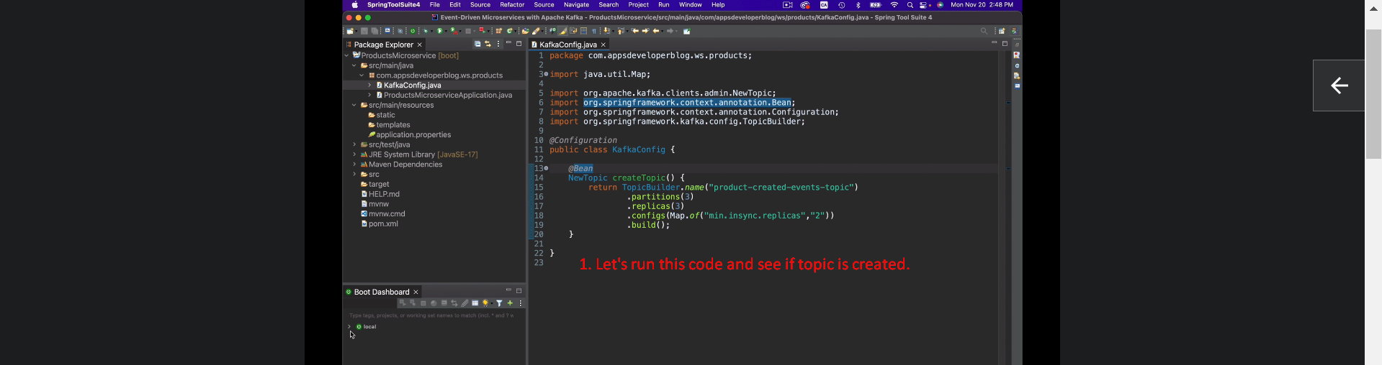
3. 